

**Asset Practice Answers: Mathematics**

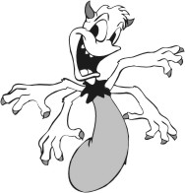1. Look at this monster.

How would you count the total number of hands on 15 such monsters?

A.15 + 4

B. 15 - 4

C. 4 + 15

**D. 4 x 15**

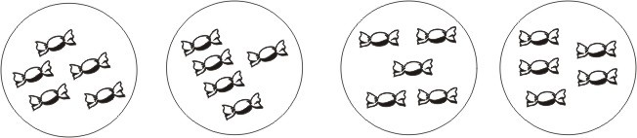2. Look at the picture below.

Which of the following facts does this picture show?

A. 18 + 2 = 20

B. 4 + 5 = 9

C. 4 + 4 + 4 + 4 = 16

**D. 4 x 5 = 20**

3. 5 ×



= 5

Which of these can come in ?

**A. 1**

B. 2

C. 5

D. 0

4. What should be added to 4 × 5 to get 4 × 6?

A. 1

**B. 4**

C. 5

D. 6

5. What is 3 times 13?

A. 16

**B. 39**

C. 133

D. 313

6. How much MORE is 4 × 9 than 4 × 8?

A. 36

B. 32

C. 9

**D. 4**

7. A tailor has to put 5 buttons on a shirt. How many buttons will he need for 12 shirts?

A. 12 + 5

**B. 12 × 5**

C. 5 + 5 + 5 + 5 + 5

D. 12 × 12 × 12 × 12 × 12

8. Which of these is equal to 9?

A. 9 × 0

**B. 1 × 9**

C. 1 + 9

D. 9 - 1

9. As shown in the picture below, there are some loose beads and some beads in jars. Each jar contains

10 beads.

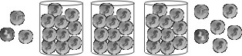

How many beads are there in all?

A. 12

B. 36

**C. 39**

D. 120

10. What number comes just BEFORE 5 tens?

**A. 49**

B. 40

C. 14

D. 4

11. 7 ones + 9 tens = A. 16

B. 27

C. 79

**D. 97**

12. What are the next two numbers in the pattern? 8, 13, 18 , 23, , **A. 28 and 33**

B. 33 and 43

C. 33 and 35

D. 38 and 43



**Maths**

1. D: The monster in the figure has 4 hands. 2 such monsters will have 4 + 4 hands. 15 such monsters will have 4 + 4 +

4...4 (15 times). Adding 4 fifteen times is the same as 4 × 15. So 15 such monsters will have 4 × 15 hands.

2. D: There are 4 circles each having 5 toffees. So there are 5 + 5 + 5 + 5 toffees. 5 + 5 + 5 + 5 = 4 × 5. And 4 × 5 = 20.

So the given picture shows the fact that 4 × 5 = 20.

3. A: 5 × 1 = 1 + 1 + 1 + 1 + 1. So 5 × 1 = 5. Hence A is the answer.

4. B: 4 × 5 = 4 + 4 + 4 + 4 + 4. 4 × 6 = 4 + 4 + 4 + 4 + 4 + 4. So 4 × 6 = (4 + 4 + 4 + 4 + 4) + 4.

That is, 4 × 6 = (4 × 5) + 4. So 4 should be added to 4 × 5 to get 4 × 6. 4 × 5 = 20 and 4 × 6 = 24. 24 is 4 more than 20

and not 1 more than 20. Hence B is the answer and not A.

5. B: 3 times 13 is the same as 13 + 13 + 13. And 13 + 13 + 13 = 3 × 13, which is 39. Hence B is the answer. 16 is 3 more than 13 and not 3 times 13. So A cannot be the answer.

6. D: 4 × 9 = 36. 4 × 8 = 32. How much more than 32 is 36? 4, right? Hence D is the answer and not A.

7. B: A tailor has to put 5 buttons on a shirt. He has to put 5 + 5 = 2 × 5 buttons on two shirts. How many buttons he will need for 12 shirts? 12 × 5 buttons, right?

8. B: What is 9 × 0? Is it not 0 + 0 + ...0 (9 times)? That is the same as 0. So, 9 × 0 = 0.

1 × 9 = 9. 1 + 9 = 10 and 9 - 1 = 8. So 9 is equal to 1 × 9 and B is the answer.

9. C: Each jar contains 10 beads. So the 3 jars will contain 3 × 10 = 30 beads. There are 9 loose beads, 3 to the left of the

first jar and 6 to the right of the last jar. So totally there are 30 + 9 = 39 beads.

10. A: How will you express 50 in terms of tens and ones? 50 = 5 tens, right? So the number just before 5 tens is the number

before 50. This will be 49.

If you read the question carefully, you will see that it asks for the number before 5 tens and not 5. So D cannot be the

answer.

11. D: 9 tens = 90. 7 ones = 7. So 7 ones + 9 tens = 7 + 90 = 97. Hence D is the answer.

The question does not ask for 7 ones + 9 ones. So 16 cannot be the answer.

12. A: 13 is 5 more than 8. 18 is also 5 more than 8. Isn't 23 also 5 more than 18? So the next number in the pattern would

be 5 more than 23 which is 28. The number next to it will be 28 + 5, which is 33. Thus the pattern would be 8, 13, 18, 23,

28, 33.